**INTERACTION DIAGRAMS**

**SEQUENCE DIAGRAM**

1. Activation of application

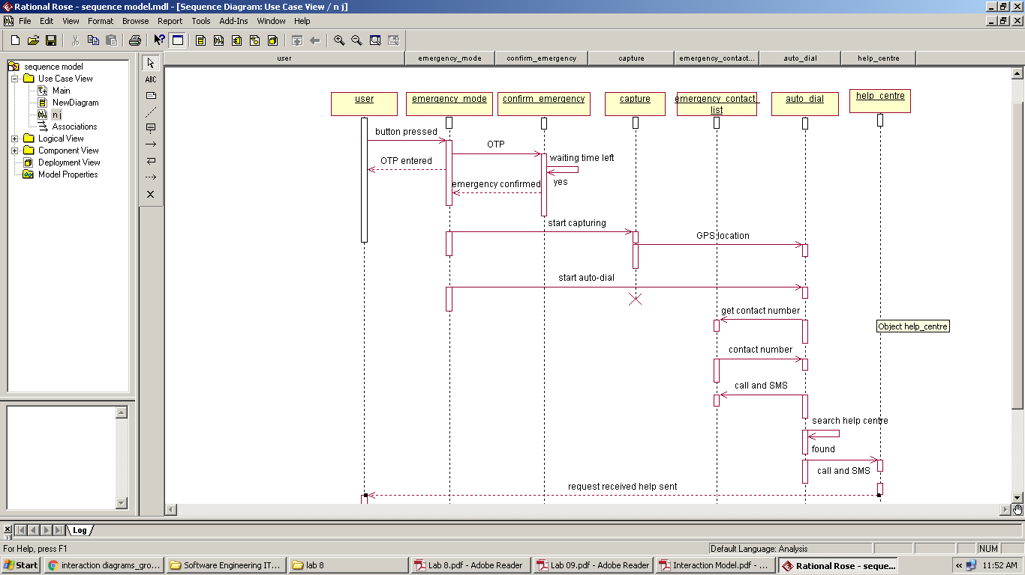

2. Calling the help centre manually

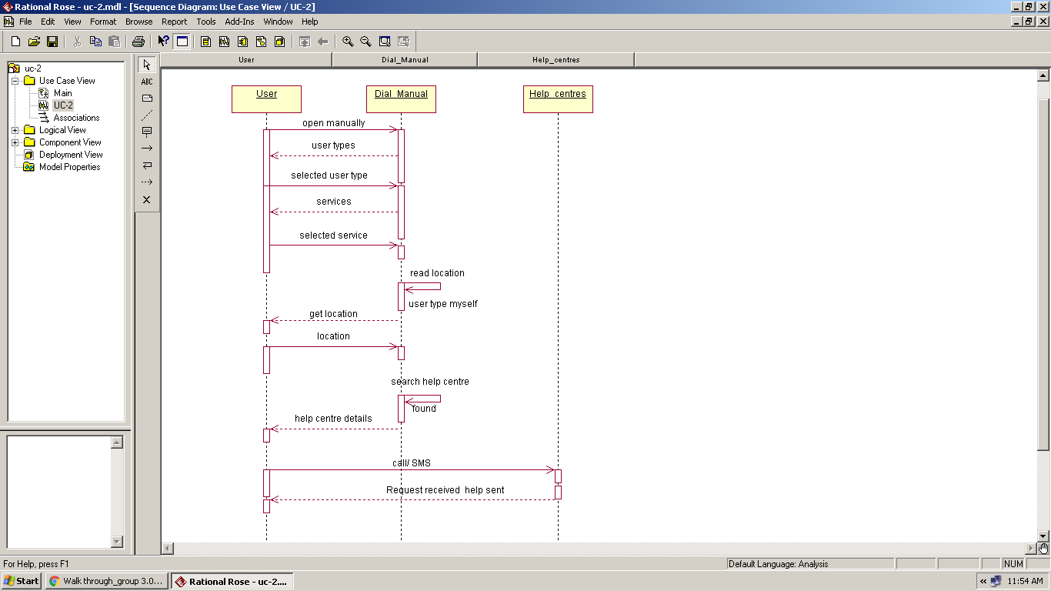

3. Registration on the system

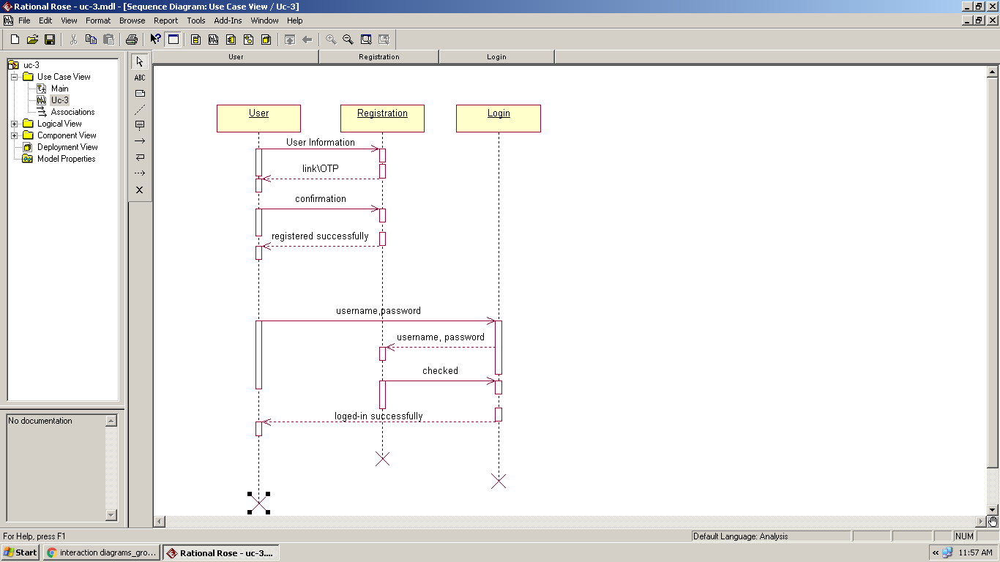

**COLLABORATION DIAGRAMS**

1.

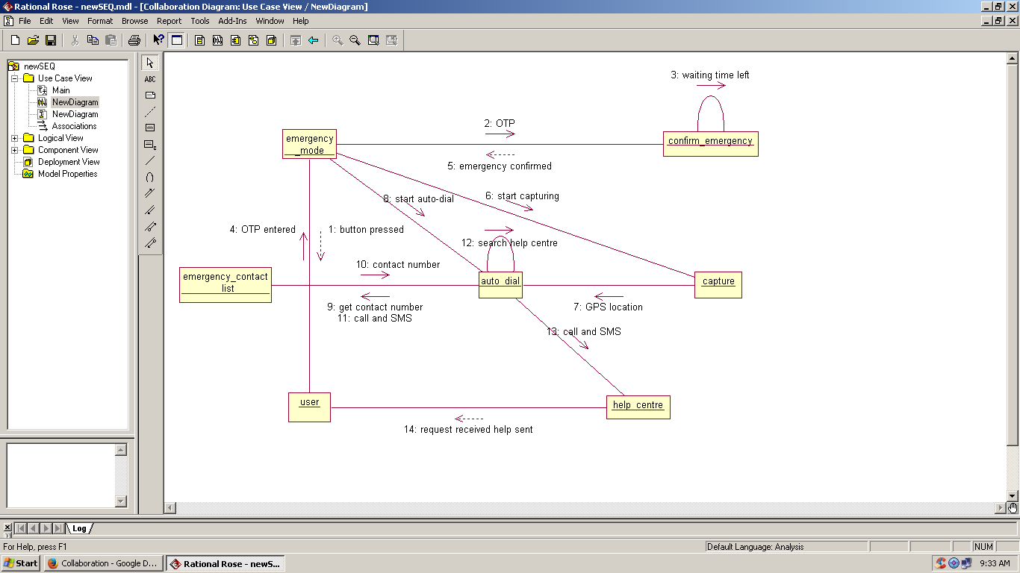

2.

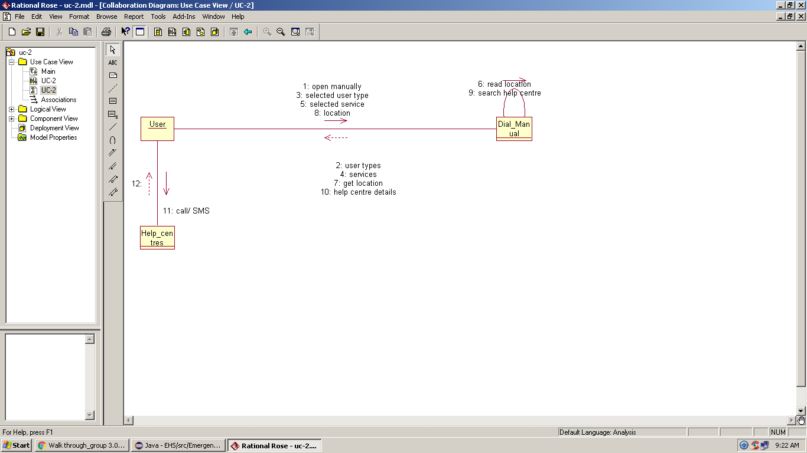

3.

